Avi Multi-faith Shabbat
This Friday, February 26
6-8 pm at the Jewish Student Center
216 Summit St
(cross Brodhead from Alumni and look for first house on the left of Summit St)

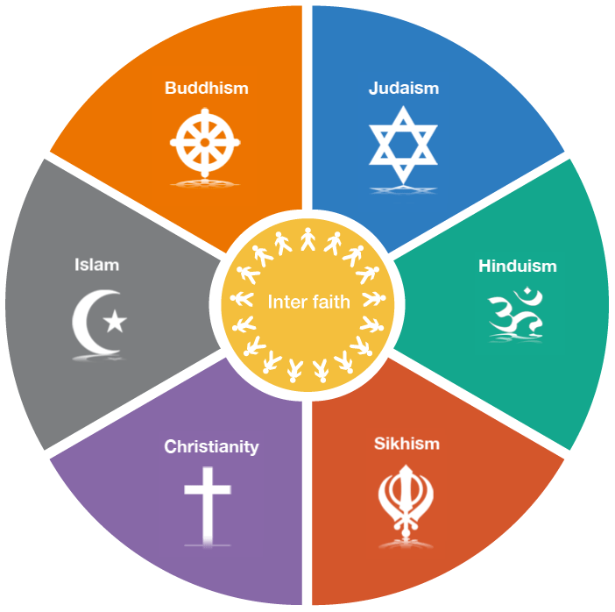

Have you ever wanted to talk about religion with your friends or roommates, but haven’t known how to start? Come to the Jewish Student Center this Friday to experience a Shabbat service and dinner, and to have open conversation about our religious or non-religious backgrounds over a delicious meal.*

Everyone is welcome, whether you consider yourself religious or not!

This Shabbat is generously sponsored by the Avi Schaefer Fund
and by the Philip and Muriel Berman Foundation.

*Food is kosher and fish is being served this Shabbat

