Inter-Religious Rome
A Program of the Dialogue Center

A Report to Lehigh

The Students and Faculty/Staff Leaders of the recent “Inter-Religious Rome” trip invite the Lehigh campus to an “eat-and-greet” discussion to hear students reflect on their recent Spring Break trip to Rome. Come eat pizza and listen as students from the trip share pictures and discuss the significance of their inter-religious dialogue encounters in Rome, including the audience with Pope Francis and visits to the Great Synagogue and the Grand Mosque, Europe’s largest.

The Dialogue Center
661 Taylor Street
Monday, April 20

4:30 p.m.
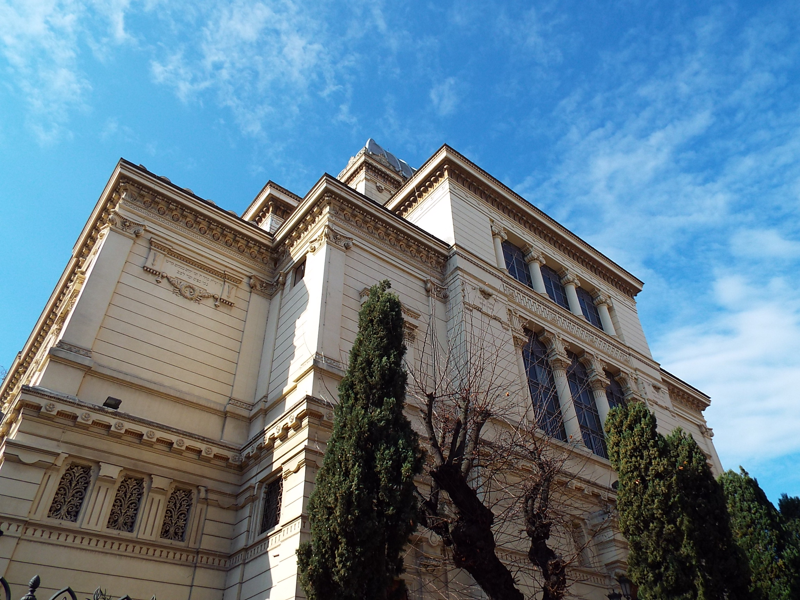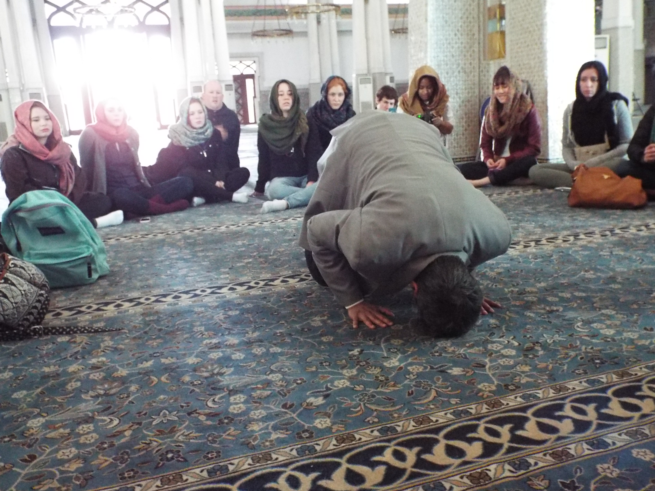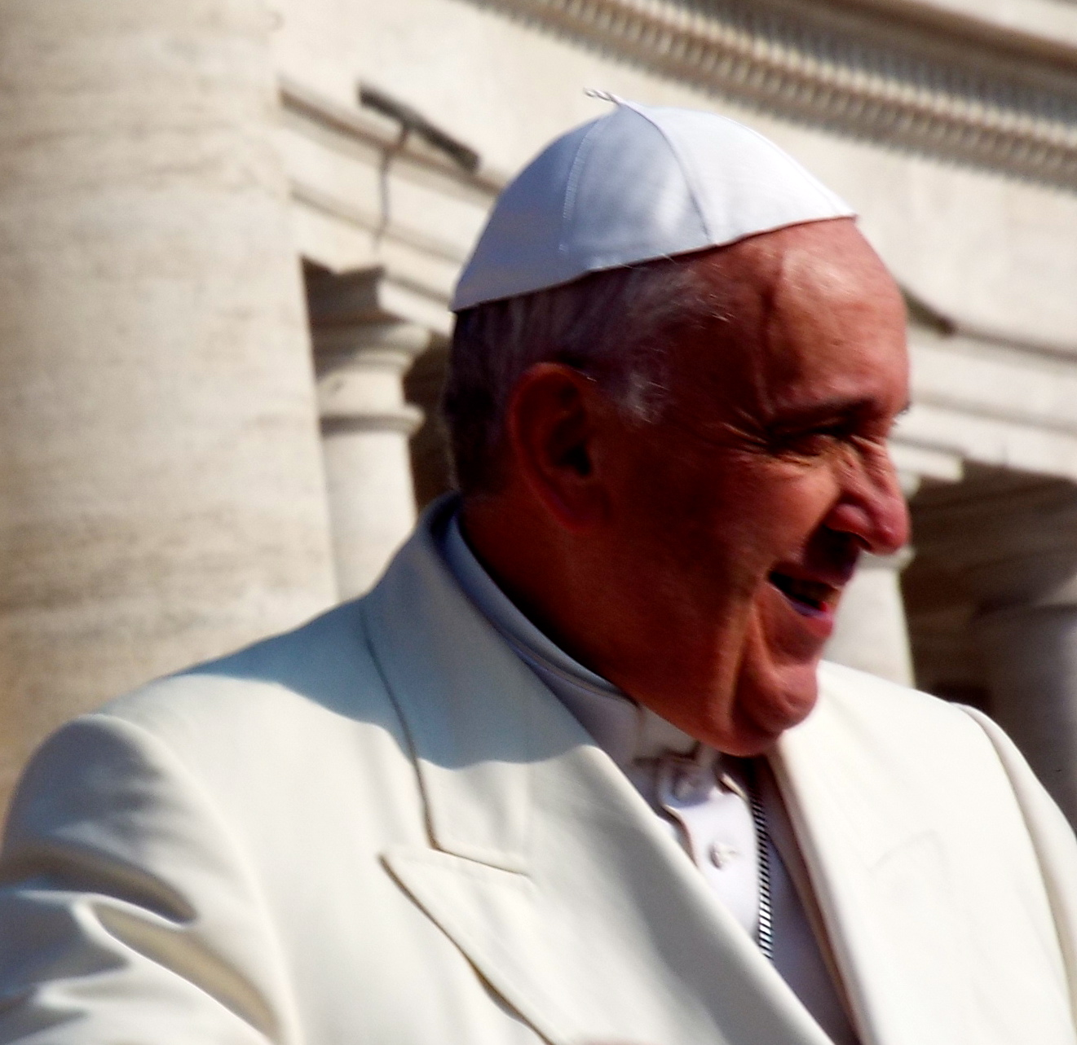

All Welcome
For more information contact The Dialogue Center (Chaplain’s Office) at x 83877.

